# **[Trevor Appleton](http://trevorappleton.blogspot.ca/)**

Tutorials, Hints and Tips about the Raspberry Pi and Python.

## **Monday, 1 April 2013**

### **Installing MediaWiki on a Raspberry Pi**

I cannot sing the praises of MediaWiki highly enough. For those who don't know, MediaWiki is the program which is used for Wikipedia. I introduced the company I work for to MediaWiki so they could use it as a repositry for all the information about projects, HR, Finance, IP etc. Basically anything which should be written down and referred to in the future is stored in the wiki.

As an experiment I installed MediaWiki on my Raspberry Pi. I was surprised how well it ran and thought I would share with you the installation process for this. That way you can have your own personal wiki to store information about your school, information about your projects, or even information about your Raspberry Pi. In short anything which you normally jot down can be stored in the wiki and easily retrieved...

Before we get onto the installation of MediaWiki its worth pointing out that you are installing a LAMP server onto your Raspberry Pi. So what does LAMP stand for? It stands for Linux, Apache, MySQL and PHP.

* Linux, you should all be familiar with, I hope. :-)
* Apache is a web server. You will be connecting to the wiki remotely, via a web browser, from another machine.
* MySQL is a database to store all the information from the wiki.
* PHP is a programming language used for web applications.

Sometimes the P in LAMP stands for other programming languages such as Python or Perl. But in this case it stands for PHP.

OK enough talking on with it!

**Installation**

Most of the installation will be through the command line. You can do this directly through LXTerminal (the icon for this is on the Raspberry Pi desktop) or [accessing your Raspberry Pi remotely via SSH.](http://trevorappleton.blogspot.co.uk/2013/03/ssh-into-raspberry-pi.html)

sudo apt-get update



sudo apt-get install mediawiki



You will shortly be asked for a password for MySQL. It is a good idea to set a password at this time.

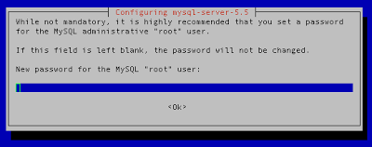

You are then asked to repeat your password. This ensures you have typed it in correctly.

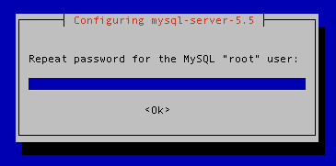

Now you need to modify a file called apache.conf. This file is stored in the 'mediawiki' folder, which in turn, is inside the 'etc' folder. We can modify this using a text editor called nano through the command line. To do this type:

sudo nano /etc/mediawiki/apache.conf



We need to remove the # from the third line down so it changes from

#Alias /mediawiki /var/lib/mediawiki

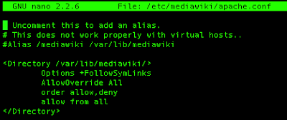

to

Alias /mediawiki /var/lib/mediawiki

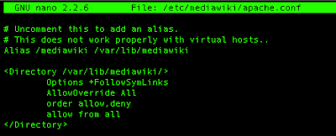

As we are doing this in the command line you need to move down to the start of the third line by pressing the down arrow on the keyboard twice. To delete the # press the delete key.

Now to save the file you need to press Ctrl-X (Press the control key and while holding this down, press the X key). A message will appear asking if you want to save the file.



Press Y and then return.

Great you have just modified your file using only the command line.

Next you need to install php-apc for object caching and Imagemagick for thumbnailing.

Lets do both these together shall we?

sudo apt-get install php-apc imagemagick



press Y when asked do you want to continue.

Dont worry if you find one of these has already been installed.

You now need to restart the apache server by typing.

sudo apache2ctl restart



Right thats all we can do by SSH for now.

We now need access to the desktop on the Raspberry Pi. If you want to remotely access your Raspberry Pi desktop follow these [instructions to VNC into the Raspberry Pi](http://trevorappleton.blogspot.co.uk/2013/03/remotely-connect-to-raspberry-pi-desktop.html) first. If you are directly connected, or have already connected via VNC, then the first thing you need to do is open your web browser.

When I first wrote this blog post the choice of default web browsers on the Raspberry Pi was poor, and you had to install Chromium to carry out the next stage. Since then the Epiphany Web Browser has been released, and now ships with the Raspberry Pi as default. This allows you to complete the installation of MediaWiki.

Open up the Epiphany Web Browser and type the following web address into the address bar at the top.

http://localhost/mediawiki



Which should now take you to a web address with the following icon and information below it.



Click on the blue text below which says "set up the wiki"

The first screen asks you to select your language. If you are happy with the default options, then you can just click on Continue.

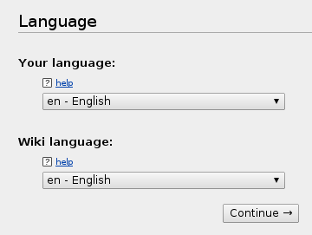

The next page shows that some Environmental Checks have been carried out.

Approximately halfway down the page you should see the following message.



There is nothing you need to type in this window, so you can click on continue at the bottom.



The next screen is titled Connect to database. There are 6 fields in this screen:

The first two options are Database type and Database host.

The top field labelled Database Type, should be left as default which is MySQL.

Next we have the Database host, leave this as localhost.

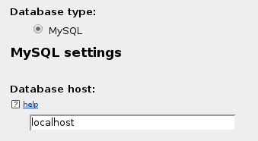

For Database name, I leave this as the default my_wiki, there is no real reason to change this.

Next we have the Database table prefix. Leave this blank.

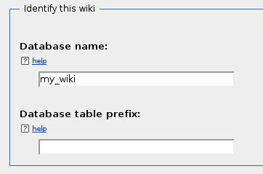

Leave the Database username as root.

Which leaves only the last field on this page which you need to input something into, the Database password. Enter the password you entered at the beginning of the installation process when asked for the MySQL password.

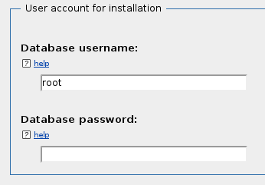

Then click continue.



The next screen entitled Database Settings has three options, which should be left on the default settings.

Database account for web access, leave the Check box "Use the same account for installation" checked.

Storage Engine, the default InnoDB option should be used.

Database character set, again leave this as Binary.

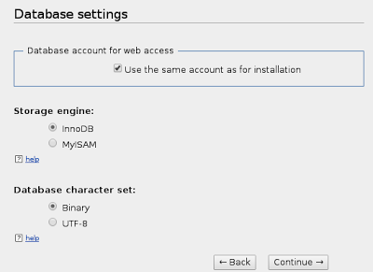

Click on Continue



The next page is titled Name and is where you personalise the name of your wiki.

The top field is for the name of the wiki. You can enter what you want in here, but I will call mine TrevorWiki.

The second field is the Project namespace, leave this option as the default, which is Same as the wiki name.

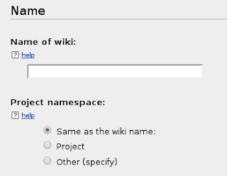

The third line is for the wiki administrators name. I am going to put Wiki Admin in here.

The next two boxes are for your password. So enter the password into both boxes.

Enter your E-mail address in the next field if you want to. I tend to leave this blank.

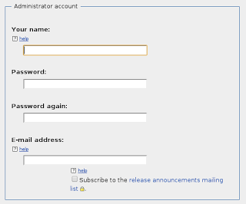

Finally there is a box asking if you want to be asked more questions, or if you are bored and want to install the wiki. I opt for more questions, which is the default option.

If you are, as the options suggest, bored, then please feel free to choose the other option!

Then click Continue.

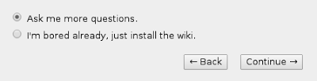

The Options screen.

I leave the wiki as a Traditional wiki, which is the default option.

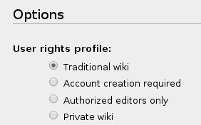

For Copyright and license, I leave this as the default option which is No license footer.

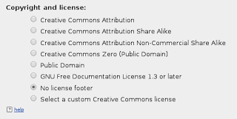

For the E-mail settings, I leave all these as standard.

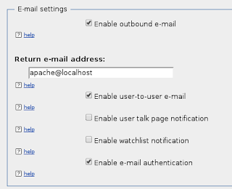

Extensions, I leave all these as standard.

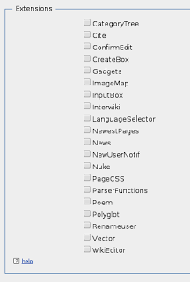

Images and file uploads, I check the enable file uploads box (shown here unchecked).

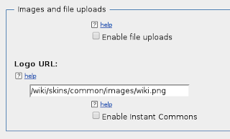

Finally in the Advanced configuration. Select PHP object caching (APC, XCache or WinCache)

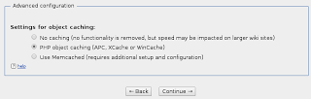

Then click on Continue

The next screen is titled Install. By clicking on Continue, you will begin the installation.

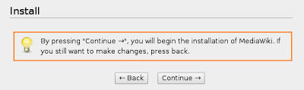

This might take a few minutes.

You should now see a window which shows all parts of the install is complete.

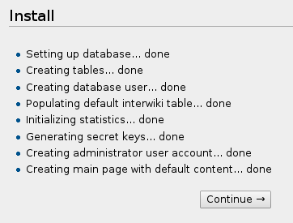

Click Continue.

You should now have a window which says Congratulations!

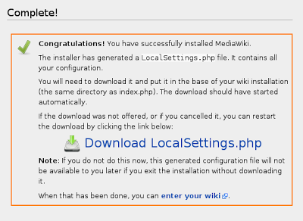

Very nearly there! Reading this message it states that you have generated a LocalSettings.php file. You now need to download it and put it in the base of your wiki installation (the same directory as index.php)

This file should have downloaded automatically, but if not you can click on the Download LocalSettings.php icon.

To move this file to the right place.

Via SSH type

sudo mv Downloads/LocalSettings.php /var/lib/mediawiki



At the moment the wiki is only displayed in text mode. You need to modify one line in the LocalSettings.php to rectify this.

To modify the LocalSettings.php file type the following into the command line.

sudo nano /var/lib/mediawiki/LocalSettings.php



Press the down arrow until you get to the line which says:

$wgServer = "http://localhost"

and comment this out by placing a # in front of it.

#$wgServer = "http://localhost"



Press Ctrl-X to save the changes

Press Y when asked if you want to save the modified buffer.

Press return when asked to save the file LocalSettings.php

Congratulations, you have now installed MediaWiki!

To access the MediaWiki server from another computer on your network. Load a web browser from a computer on your network, and type the following into the webbrowser

http://IPaddress/mediawiki/index.php/Main_Page

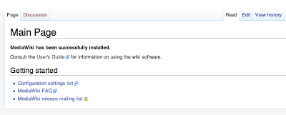

Replacing IPaddress with the IP address of the MediaWiki server. If you do not know what the IP address of your Raspberry Pi is you can find it by following this blog post on [remotely finding your Raspberry Pi IP address.](http://trevorappleton.blogspot.co.uk/2013/03/remotely-find-raspberry-pi-ip-address.html)

Watch out for future posts explaining more about MediaWiki!

Posted by [Trevor Appleton](https://plus.google.com/103546489528241855485) at [13:34](http://trevorappleton.blogspot.ca/2013/04/installing-mediawiki-on-raspberry-pi.html)

[Email This](https://www.blogger.com/share-post.g?blogID=8250429656532783188&postID=4103629849447185739&target=email)[BlogThis!](https://www.blogger.com/share-post.g?blogID=8250429656532783188&postID=4103629849447185739&target=blog)[Share to Twitter](https://www.blogger.com/share-post.g?blogID=8250429656532783188&postID=4103629849447185739&target=twitter)[Share to Facebook](https://www.blogger.com/share-post.g?blogID=8250429656532783188&postID=4103629849447185739&target=facebook)[Share to Pinterest](https://www.blogger.com/share-post.g?blogID=8250429656532783188&postID=4103629849447185739&target=pinterest)

Labels: [MediaWiki](http://trevorappleton.blogspot.ca/search/label/MediaWiki), [Raspberry Pi](http://trevorappleton.blogspot.ca/search/label/Raspberry%20Pi)

[Newer Post](http://trevorappleton.blogspot.ca/2013/04/basic-python-programming-word-checker.html) [Older Post](http://trevorappleton.blogspot.ca/2013/03/keeping-your-raspberry-pi-updated-with.html) [Home](http://trevorappleton.blogspot.ca/)

Subscribe to: [Post Comments (Atom)](http://trevorappleton.blogspot.com/feeds/4103629849447185739/comments/default)

[](http://trevorappleton.blogspot.com/feeds/4103629849447185739/comments/default) [](http://uk.linkedin.com/in/trevorappleton) [](https://plus.google.com/u/0/+TrevorAppleton/posts) 

## **Follow by Email**

|  |  |
| --- | --- |
|  |  |

|  |
| --- |
|  |

## **Labels**

[Camera](http://trevorappleton.blogspot.ca/search/label/Camera) (3) [Game of Life](http://trevorappleton.blogspot.ca/search/label/Game%20of%20Life) (2) [Graphs](http://trevorappleton.blogspot.ca/search/label/Graphs) (2) [GUI](http://trevorappleton.blogspot.ca/search/label/GUI) (3) [Linux](http://trevorappleton.blogspot.ca/search/label/Linux) (3) [Mac](http://trevorappleton.blogspot.ca/search/label/Mac) (2) [MediaWiki](http://trevorappleton.blogspot.ca/search/label/MediaWiki) (2) [OpenCV](http://trevorappleton.blogspot.ca/search/label/OpenCV) (1) [Pygame](http://trevorappleton.blogspot.ca/search/label/Pygame) (5) [Python](http://trevorappleton.blogspot.ca/search/label/Python) (22) [Raspberry Pi](http://trevorappleton.blogspot.ca/search/label/Raspberry%20Pi) (20) [SFTP](http://trevorappleton.blogspot.ca/search/label/SFTP) (2) [TKinter](http://trevorappleton.blogspot.ca/search/label/TKinter) (2) [Twitter](http://trevorappleton.blogspot.ca/search/label/Twitter) (1)

## **Blog Archive**

* ►  [2016](http://trevorappleton.blogspot.ca/search?updated-min=2016-01-01T00:00:00Z&updated-max=2017-01-01T00:00:00Z&max-results=2) (2)
* ►  [2015](http://trevorappleton.blogspot.ca/search?updated-min=2015-01-01T00:00:00Z&updated-max=2016-01-01T00:00:00Z&max-results=6) (6)
* ►  [2014](http://trevorappleton.blogspot.ca/search?updated-min=2014-01-01T00:00:00Z&updated-max=2015-01-01T00:00:00Z&max-results=9) (9)
* ▼  [2013](http://trevorappleton.blogspot.ca/search?updated-min=2013-01-01T00:00:00Z&updated-max=2014-01-01T00:00:00Z&max-results=18) (18)
  + ►  [November](http://trevorappleton.blogspot.ca/2013_11_01_archive.html) (2)
  + ►  [October](http://trevorappleton.blogspot.ca/2013_10_01_archive.html) (1)
  + ►  [August](http://trevorappleton.blogspot.ca/2013_08_01_archive.html) (1)
  + ►  [July](http://trevorappleton.blogspot.ca/2013_07_01_archive.html) (2)
  + ►  [May](http://trevorappleton.blogspot.ca/2013_05_01_archive.html) (2)
  + ▼  [April](http://trevorappleton.blogspot.ca/2013_04_01_archive.html) (5)
    - [Formatting SD Card with a Mac](http://trevorappleton.blogspot.ca/2013/04/formatting-sd-card-with-mac.html)
    - [Python - Graphs With Multiple Data](http://trevorappleton.blogspot.ca/2013/04/python-graphs-with-multiple-data.html)
    - [Python - Drawing Basic Graphs](http://trevorappleton.blogspot.ca/2013/04/python-drawing-basic-graphs.html)
    - [Basic Python - Programming a Word Checker](http://trevorappleton.blogspot.ca/2013/04/basic-python-programming-word-checker.html)
    - [Installing MediaWiki on a Raspberry Pi](http://trevorappleton.blogspot.ca/2013/04/installing-mediawiki-on-raspberry-pi.html)
  + ►  [March](http://trevorappleton.blogspot.ca/2013_03_01_archive.html) (4)
  + ►  [February](http://trevorappleton.blogspot.ca/2013_02_01_archive.html) (1)

## **Popular Posts**

* 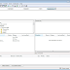
* [Remotely copy files to and from your Raspberry Pi.](http://trevorappleton.blogspot.ca/2014/03/remotely-copy-files-to-and-from-your.html)
* Most of the time I remotely log into my Raspberry Pi. Depending on what I am doing I will either SSH into it or VNC into it, which allows ...
* 
* [Python - Getting started with OpenCV](http://trevorappleton.blogspot.ca/2013/11/python-getting-started-with-opencv.html)
* A couple of years ago a colleague of mine created a program to ensure that an item I had designed was calibrated properly. The program used ...
* 
* [Writing Pong using Python and Pygame](http://trevorappleton.blogspot.ca/2014/04/writing-pong-using-python-and-pygame.html)
* Ok so imagine the year is 1973. All the talk is about a new arcade game which has been released by Atari. That game is called Pong. No...
* 
* [Installing MediaWiki on a Raspberry Pi](http://trevorappleton.blogspot.ca/2013/04/installing-mediawiki-on-raspberry-pi.html)
* I cannot sing the praises of MediaWiki highly enough. For those who don't know, MediaWiki is the program which is used for Wikipedia. I ...
* 
* [Remotely Find Raspberry Pi IP Address](http://trevorappleton.blogspot.ca/2013/03/remotely-find-raspberry-pi-ip-address.html)
* Recently I have two examples where I have needed to find devices on the local network and to establish their IP addresses. The first of th...
* 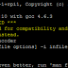
* [Creating a Time-Lapse Camera with the Raspberry Pi and Python](http://trevorappleton.blogspot.ca/2013/11/creating-time-lapse-camera-with.html)
* After the success using openCV with the Raspberry Pi camera to determine the positions of circles in an image, I thought it would be nice ...
* 
* [Python - Game of Life](http://trevorappleton.blogspot.ca/2013/07/python-game-of-life.html)
* While looking through a few programming forums I kept noticing people with a slightly odd looking avatar. I thought that for the same ...
* 
* [Basic Python - Rock Paper Scissors](http://trevorappleton.blogspot.ca/2013/05/basic-python-rock-paper-scissors.html)
* When thinking about ideas for a Python tutorial I remembered the old game, Rock Paper Scissors. This is a fun game to write in Python and in...
* 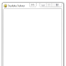
* [Guide to Creating a Sudoku Solver using Python and Pygame](http://trevorappleton.blogspot.ca/2013/10/guide-to-creating-sudoku-solver-using.html)
* After creating a version of Conways Game of Life in Python I was keen to explore Pygame further. The Game of Life program I wrote demonstra...
* 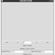
* [Creating an Animation Studio with a Raspberry Pi and Python](http://trevorappleton.blogspot.ca/2014/01/creating-animation-studio-with.html)
* When I was younger I used to love the character Morph. For those of you too young to remember, he was an animated plasticine model who appea...

|  |  |
| --- | --- |
|  |  |

|  |  |
| --- | --- |
|  |  |

Copyright © Trevor Appleton 2013. All rights reserved. Simple template. Powered by [Blogger](https://www.blogger.com).